M.LEENA SAI
BATCH_47-A

AI ASSIGNED CODING ASS-2
Task 1: Statistical Summary for Survey Data

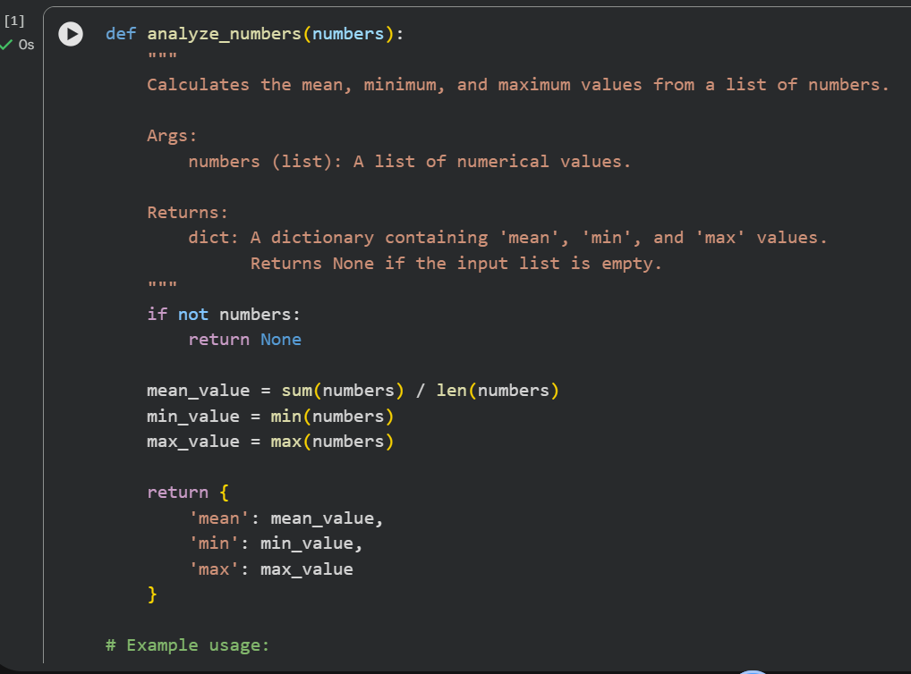
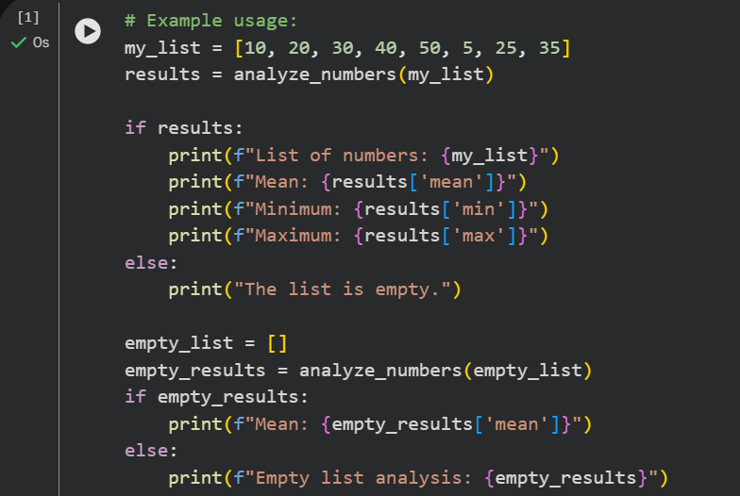

OUTPUT:

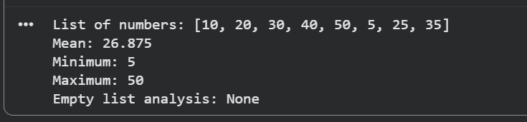
Observation:
Gemini generated a correct Python function to calculate the mean, minimum, and maximum values from a list.
The output in Colab was accurate and clearly displayed.
Overall, Gemini made the task easy by providing clear and usable code quickly.
Task 2: Armstrong Number – AI Comparison

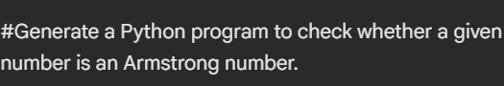

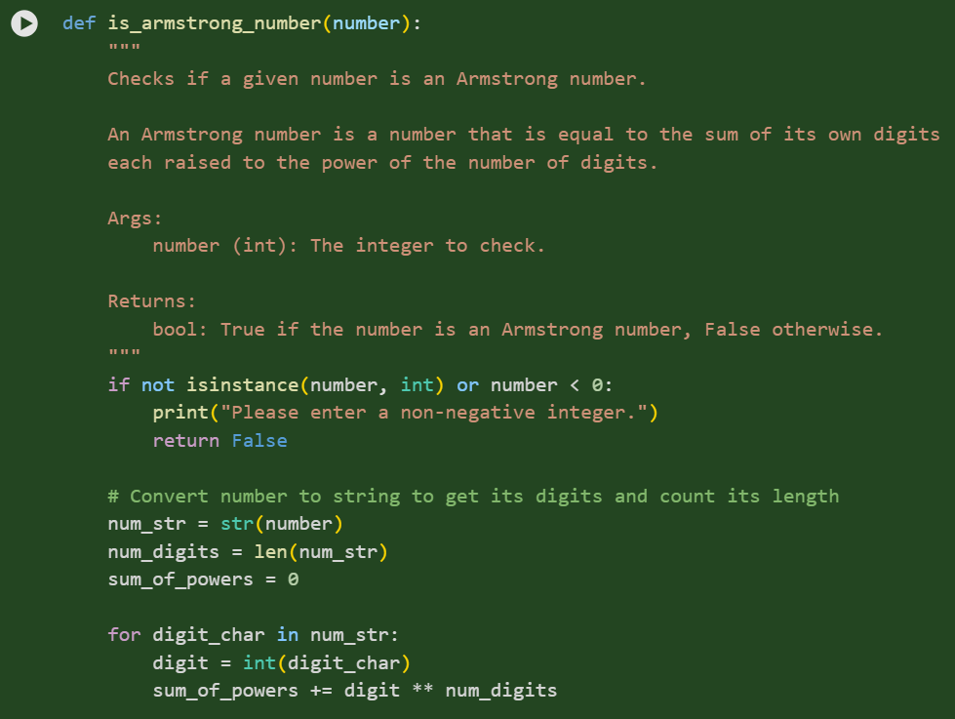

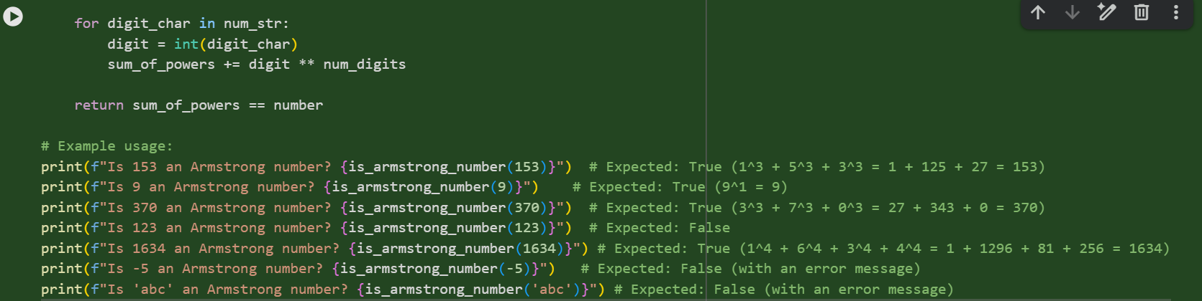

OUTPUT:
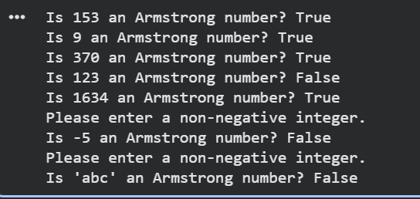
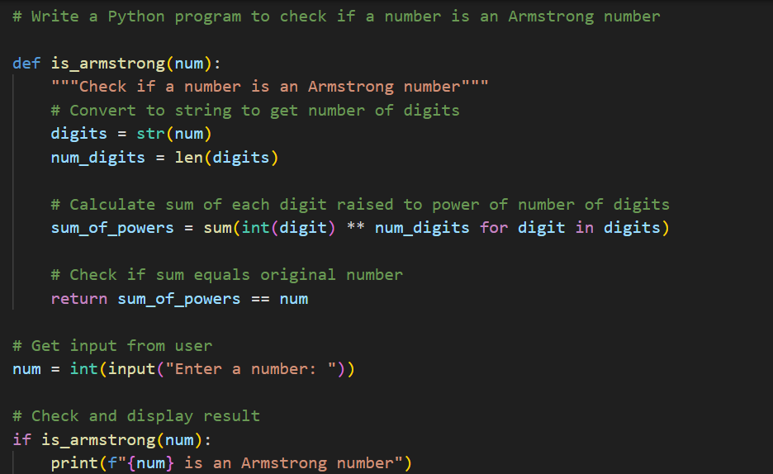
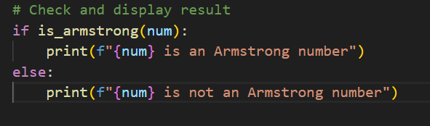

OUTPUT:
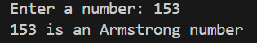

OBSERVATION:
Both Gemini and GitHub Copilot correctly generated Armstrong number checker programs.
Gemini’s code is easy to understand with step-by-step logic, making it suitable for beginners.
GitHub Copilot’s code is shorter and more optimized but slightly harder to understand.
Overall, Gemini focuses on clarity while Copilot focuses on efficiency.

Task 3: Leap Year Validation Using Cursor AI

INPUT:
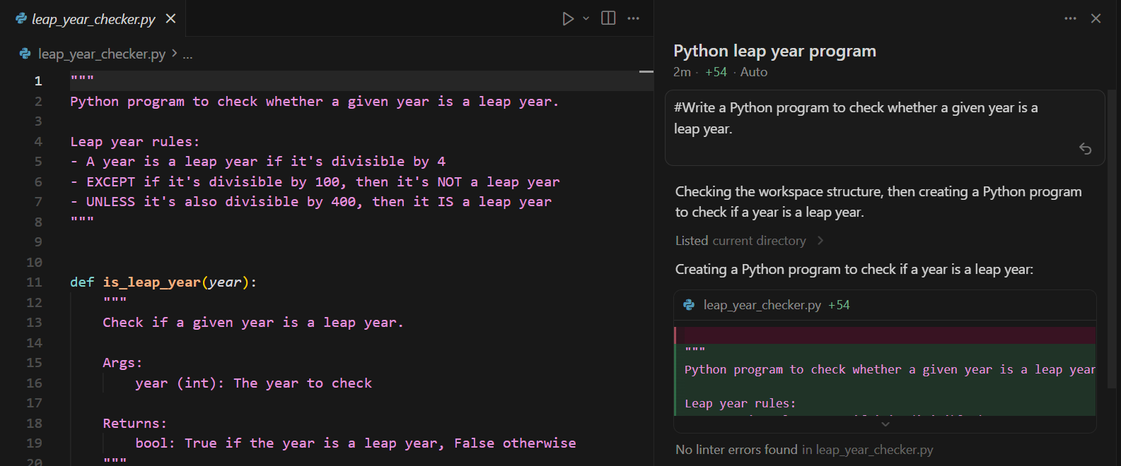

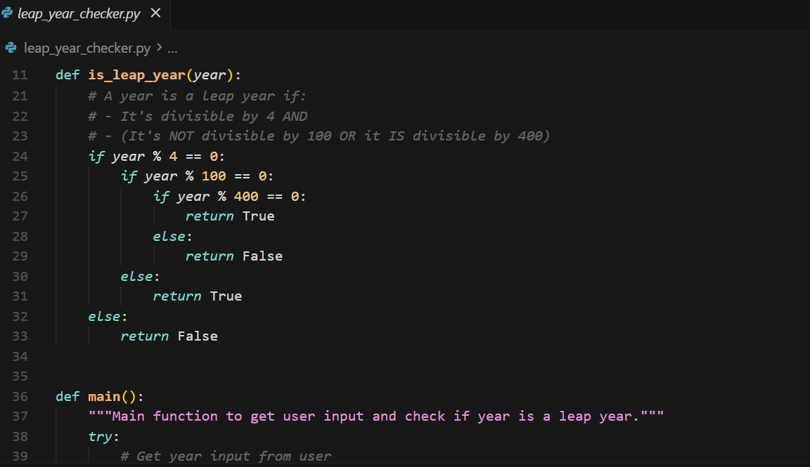

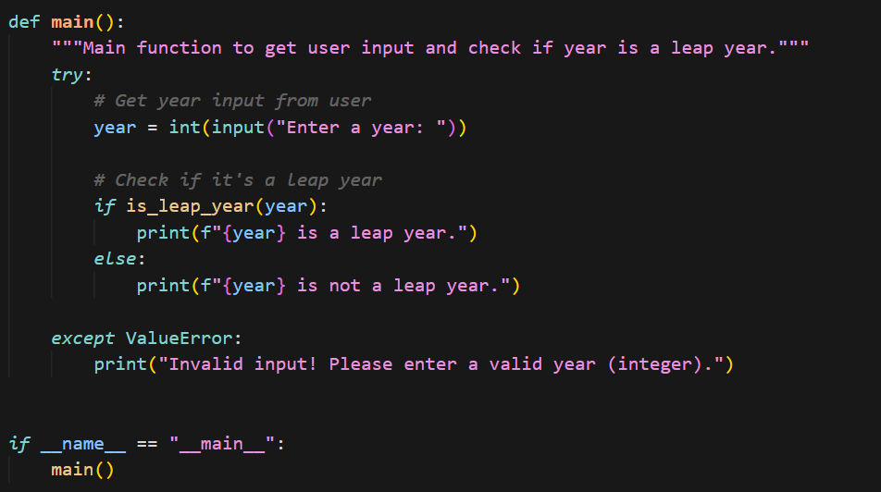

OUTPUT:
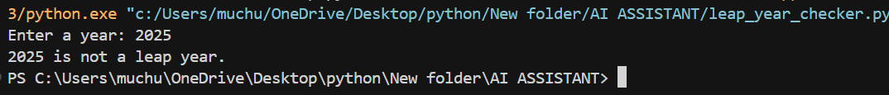
OBSERVATION:
Cursor AI generated correct leap year validation code for both prompts.
With a simple prompt, the code was basic and direct, while the detailed prompt produced cleaner and more reusable function-based code.
This shows that Cursor AI changes its coding style based on how the prompt is written.

Task 4: Student Logic + AI Refactoring (Odd/Even Sum)

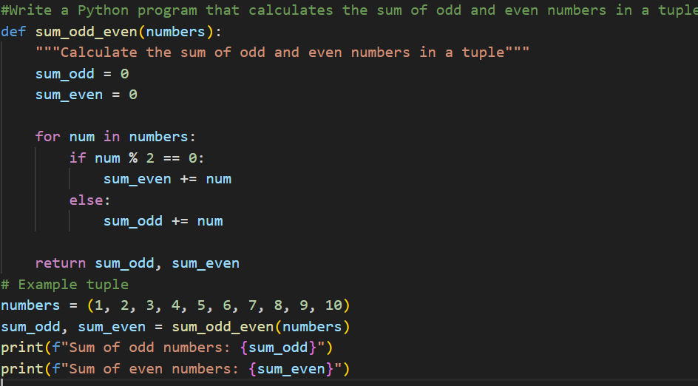
Output:
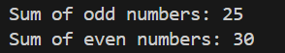
Observation:
The original code worked correctly but was lengthy.
After AI refactoring, the code became cleaner and more efficient.
AI improved readability without changing the logic.

